* **1.Ames (2004)(IPT & Mind-reading)**
* **Study 1**
  + Narcissism: 16 item-pair scale by Ames, Rose, and Anderson (2004), drawing items in each of the four factors of Emmons’ (1987) measure.
  + Self-enhancement:
    - IPT-15—objective measure;
    - self-report of estimated performance percentile among other classmates;
    - Correlation between the 2; differences between the 2; especially between the top quartile and the bottom quartile
  + 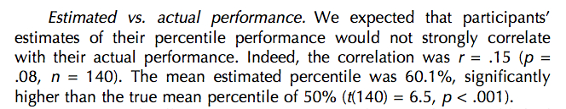
  + Narcissistic self-enhancement:
    - Correlation between narcissism and estimated percentile—r = .26
    - Correlation between narcissism and actual percentile – r = .04
* 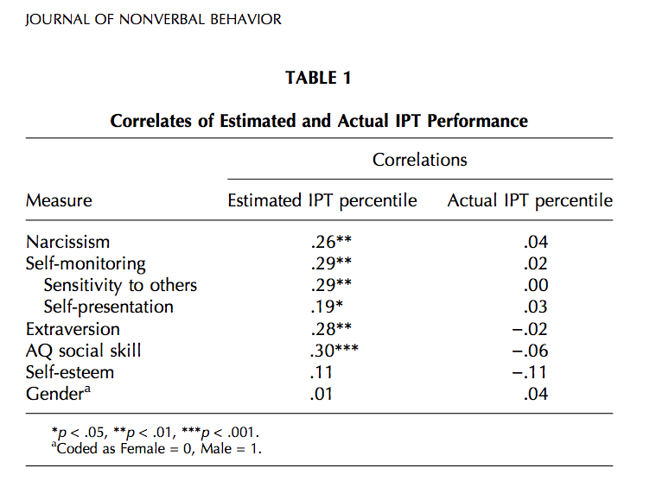
* **Study 2**
  + Self-enhancement:
    - self-report estimated performance percentile on gauging task partners’ feelings and thoughts; compared with actual accuracy of performance
  + 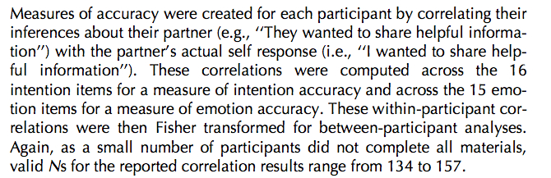
  + Narcissism: same as study 1
  + Narcissistic self-enhancement: same as study 1
* 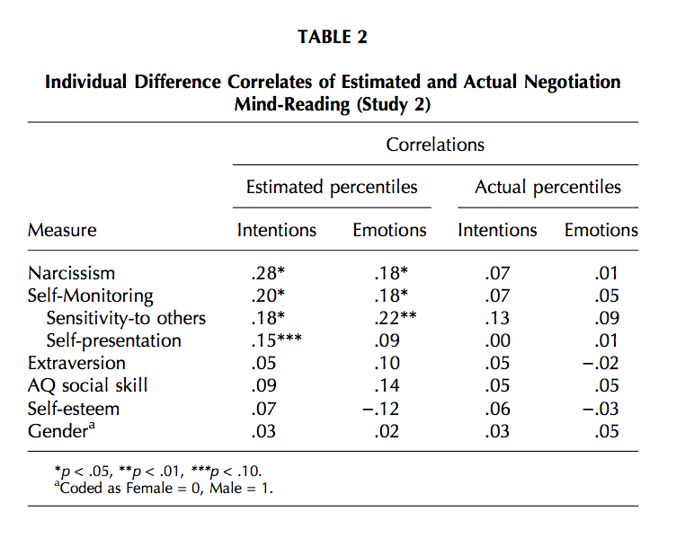
* **2.Bleske-Rechek et al. （2008）(Physical attractiveness)**
  + Narcissism: NPI-40
  + Self-enhancement:
    - Self-perceived desirability
    - A set of 24 raters rate the photos of subjects (smile, appearance, and display of resources)
    - A new set of 57 raters rated the photos again (perceived arrogance, and genuineness of smile)
  + Narcissistic self-enhancement:

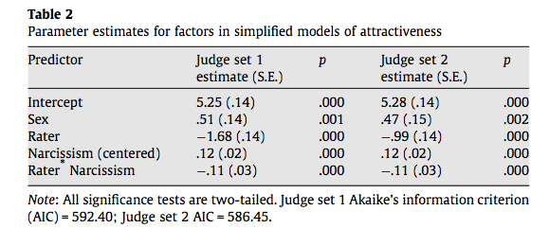

* + Looked into sex, rater, rater*narcissism, besides narcissism.
* **3.Brown (2010)(IPT)**
  + Narcissism: NPI, HSNS
  + Narcissistic self-enhancement:
    - Subtracting subjects’ estimated IPT scores from their actual IPT scores, and conducting a Pearson product-moment correlation between the difference and participants’ NPI scores.（r = .3, p<.05）
    - T-test between NPI scores of those who overestimated their IPT performance and those who underestimated, t(39) - -2.03, p = .05
* **4.Burns (2004)(Aggression)**
  + Narcissism: NPI-JO (NIP-Juvenile Offender version) (Calhoun et al., 2000)
  + Aggression:
    - Self-report using the Aggression Scale (Orpinas & Frankowski, 2001)
    - Teacher ratings: each student is rated by 2 different teachers who had known him for a period of time; used the Brief Anger-Aggression Questionnaire (BAAQ; Maiuro, Vitaliano, & Cahn, 1987)
* 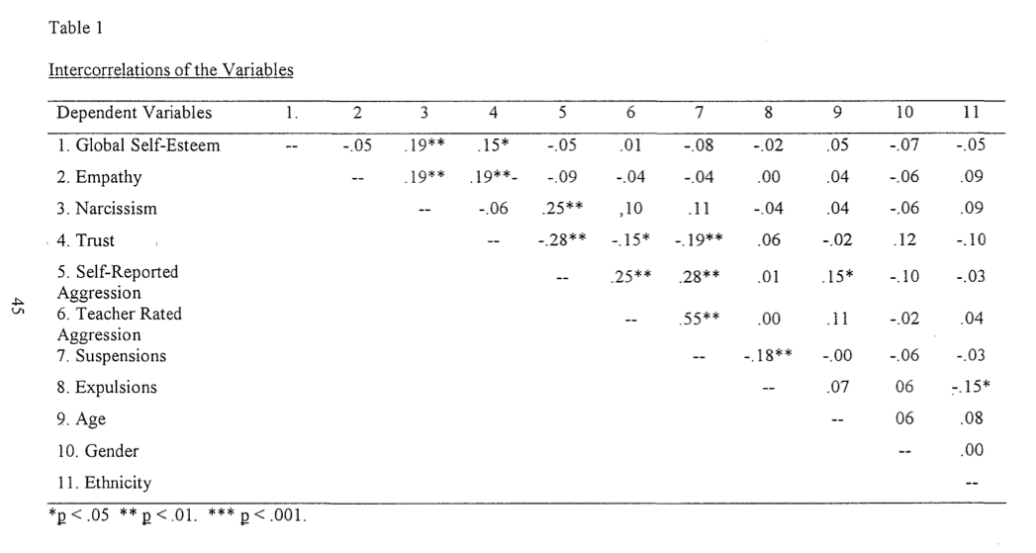
* **5.Campbell et al., (2004)(Overconfidence and risk taking)**
* **Study 1**
  + Narcissism: NPI
  + Overconfidence:
    - Answer a two-alternative forced choice version of a general knowledge question (GKQ);
    - Ask for confidence in each answer in terms of percentage ranges (confidence was take the midpoint within the selected range)
* 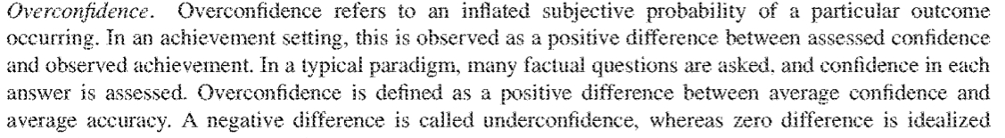
  + Narcissistic overconfidence:
    - Correlation between narcissism and overconfidence;
    - Correlation between narcissism and confidence;
    - Correlation between narcissism and accuracy
    - 🡺 Conclusion: the relationship between narcissism and overconfidence is entirely due to the relationship between narcissism and confidence, but not that between narcissism and accuracy.
* **Study 2**
  + Narcissism: NPI
  + Overconfidence:
    - Answer a two-alternative forced choice version of a general knowledge question (GKQ);
    - Ask for confidence in each answer in terms of percentage ranges (confidence was take the midpoint within the selected range)
  + Betting on answers
  + Narcissistic overconfidence:
    - Correlation between narcissism and overconfidence;
    - Correlation between narcissism and confidence;
    - Correlation between narcissism and accuracy

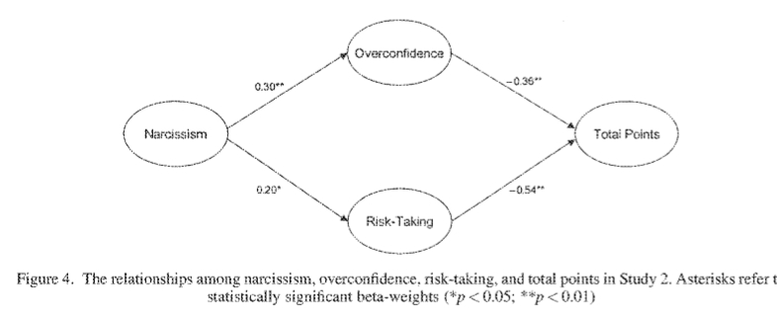

* **6.Carson et al., (2001)(Personality)**
  + Narcissism：NPI
  + Narcissistic self-enhancement: **correlation** between the NPI and others’ perceptions, self-perceptions, and self-other bias at first impression and of close other.
* 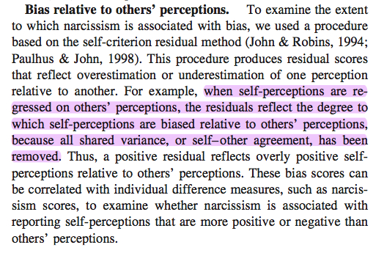
* **7.Carson et al.**
* **(2001)(Surgency attractiveness, intelligence, well-being, likeableness, narcissism, communal traits* )**
* 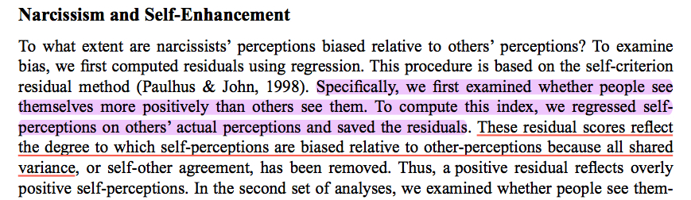
* **Correlation**
* 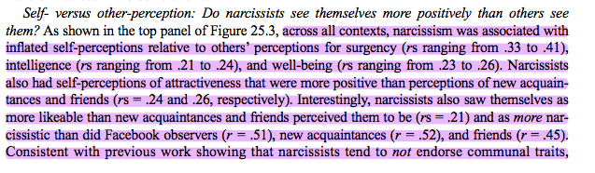
* **8.Dattner (1999) (Fairness at workplace)**
* Self-enhancement: the discrepancy between self-ratings and staff ratings.
* Narcissistic self-enhancement: **Correlation**
* 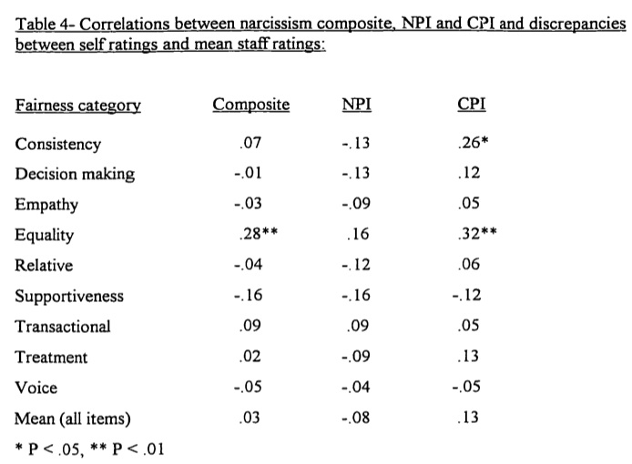
* **Some weird regression**
* 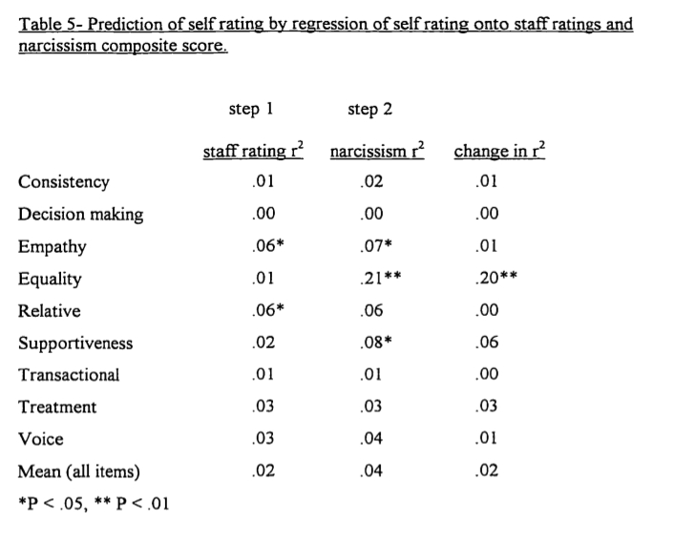
* **8-2.Farwell & Wohlwend-Lloyd (1998) ( Grades)**
* Calculate the difference between estimated and actual grades on a 4.0 point scale.
* **Study 1**: Correlation (narcissism vs. actual grades; vs. estimated grades)
* **Study 2**: Partial correlation after unexpectedly found a positive correlation between narcissism and actual grades
* 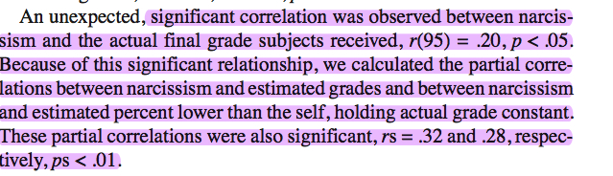
* **9.Gabriel et al. (1994) (Intelligence and physical attractiveness)---Gender**
* Self-enhancement
* 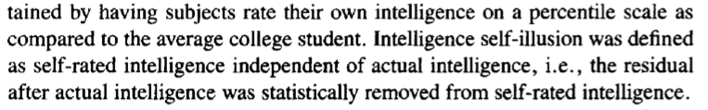
* 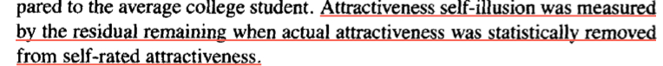
* Narcissism self-enhancement: Intercorrelation, on-way ANOVA
* 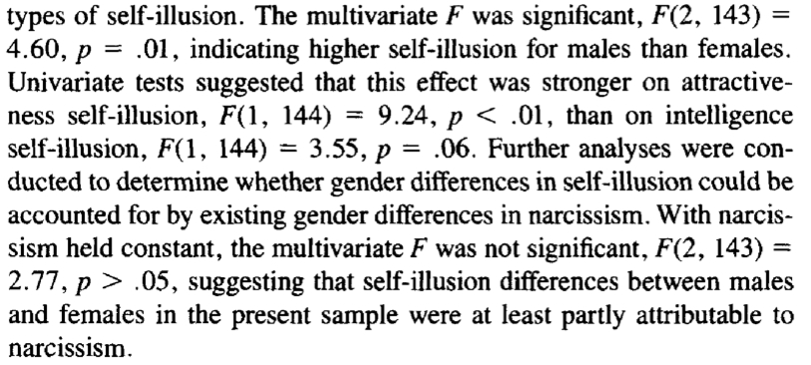
* 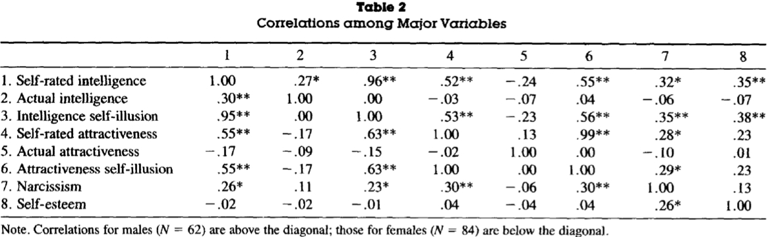
* **10.Gosling et al. (1998)(Act frequency)**
* 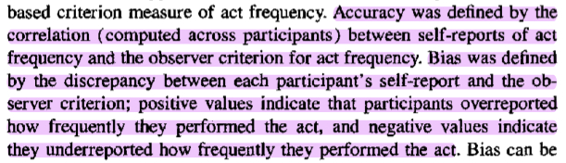
* **Narcissistic self-enhancement: Correlation**
* 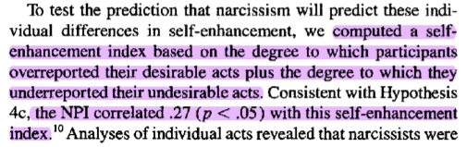
* **11.John and Robins (1994) (Job performance)**
* 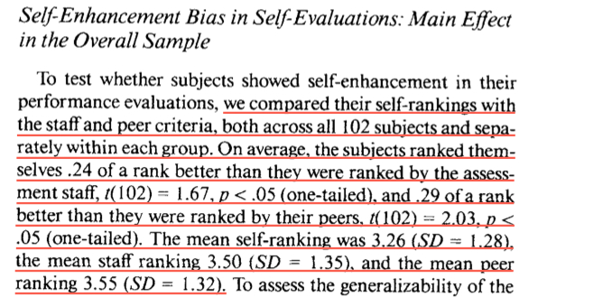
* **12. Judge (2006) (Leadership, workplace deviance, and task & contextual performance)**
* 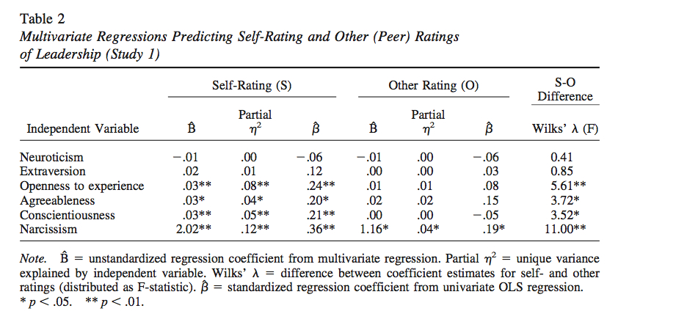
* 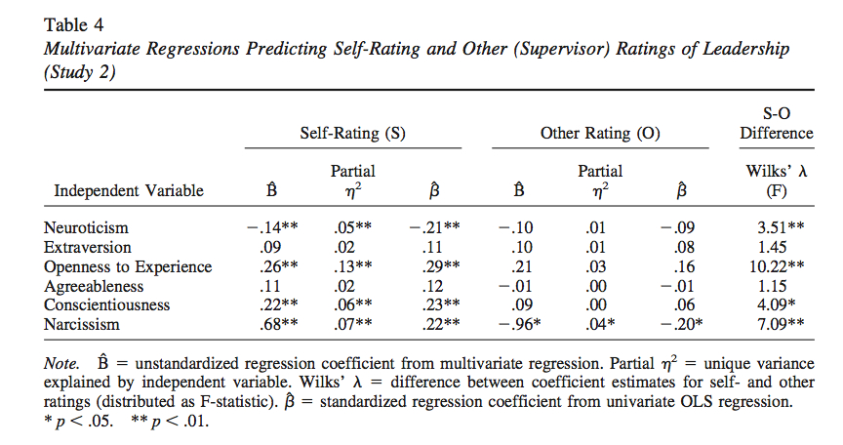
* 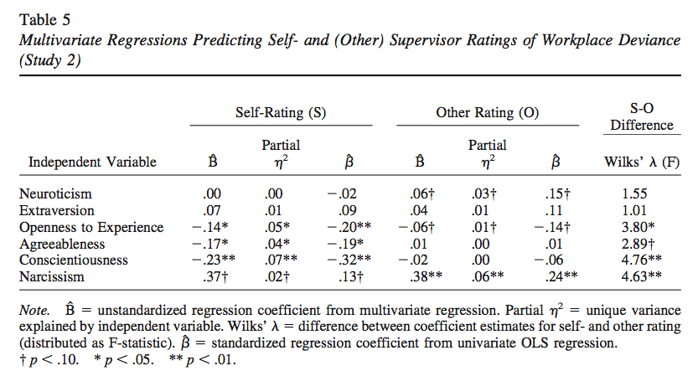
* 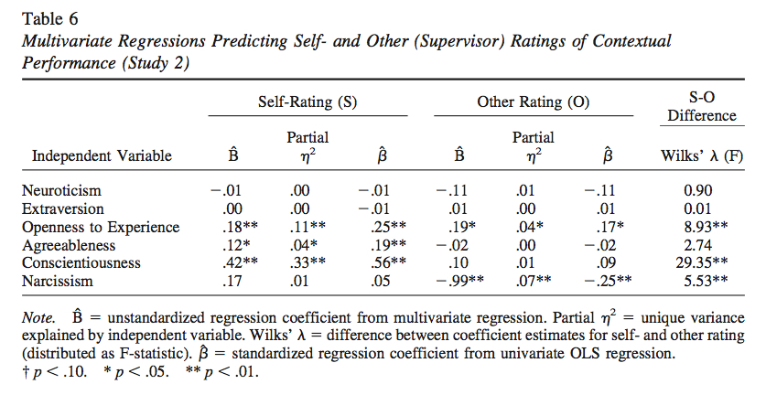
* **13. Marino (2011) (Humor)**

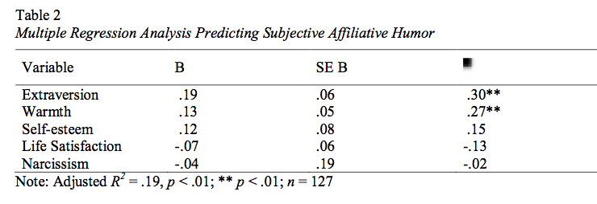

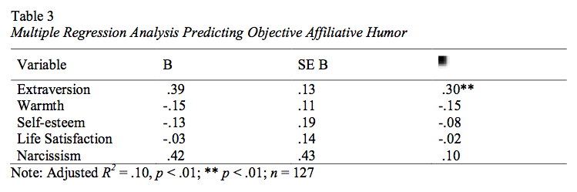

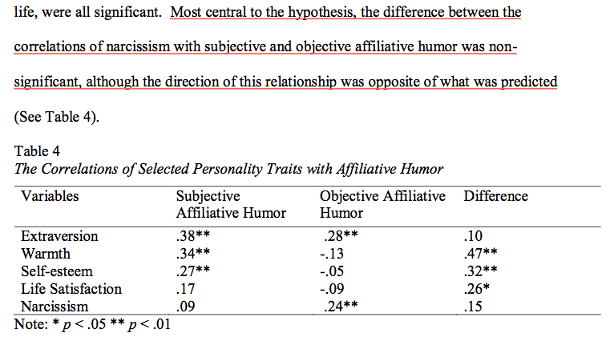

**14.Milad (2013) (Leadership)**

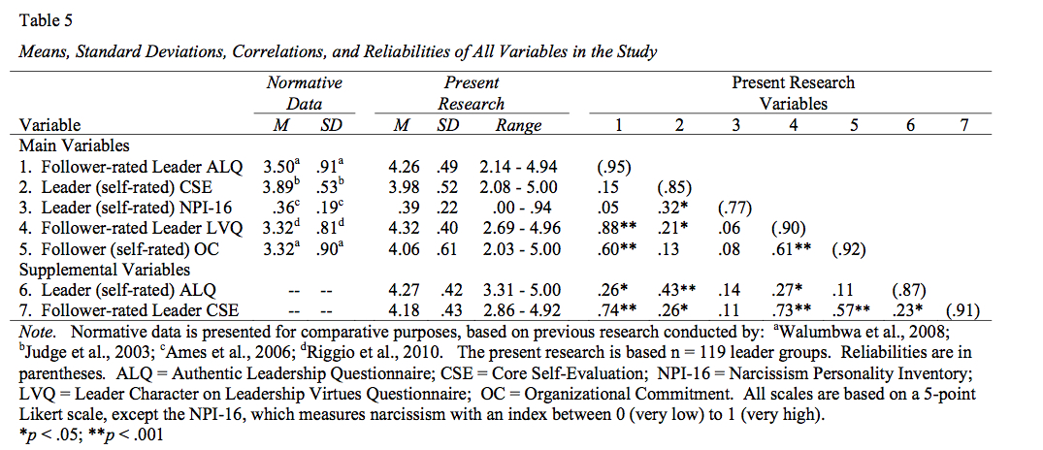

* **15. Paulus & Williams (2002) (Book chapter)**
* 
* 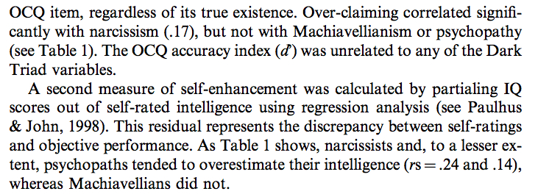
* 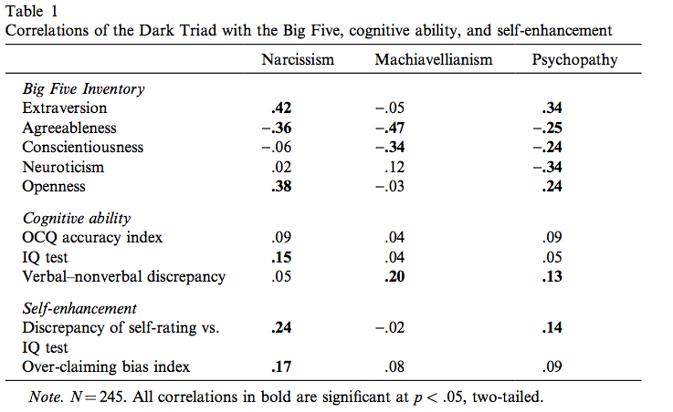
* **16. Paulhus (1998)(Interpersonal perception)**
* 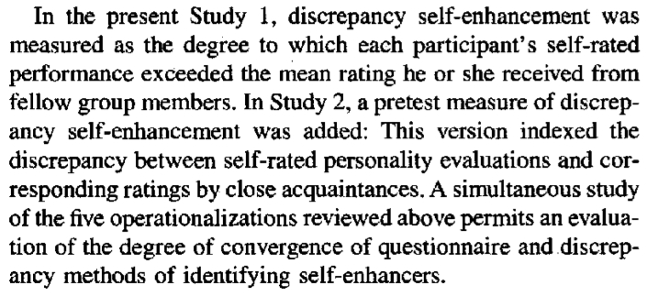
* **17. Raskin (1980) (Creativity)**
* 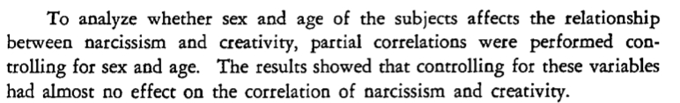
* 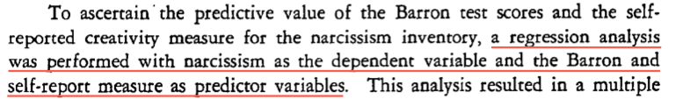
* **18. Robin and Beer (2001) (**
* **~~19. Hill & Roberts (2012)(Big Five)--Role~~**
* ~~